|  |  |
| --- | --- |
| cetlogo ***CHEMICAL ENGINEERING TRANSACTIONS***  ***VOL. 92, 2022*** | A publication of  aidiclogo_grande |
| The Italian Association  of Chemical Engineering  Online at www.cetjournal.it |
| Guest Editors: Rubens Maciel Filho, Eliseo Ranzi, Leonardo Tognotti  Copyright © 2022, AIDIC Servizi S.r.l. **ISBN** 978-88-95608-90-7; **ISSN** 2283-9216 | |

Sintering Behaviors of Synthetic Biomass Ash

Liang Wanga,\*, Michael Becidana, Daniel Lindbergb, Nora Cecilie Ivarsdatter Furuvikc, Britt Margrethe Emilie Moldestadc, Marianne Sørflaten Eikelandc

a SINTEF Energy Research, Sem Sælands vei 11, NO-7034 Trondheim, Norway

b Department of Chemical and Metallurgical Engineering, Aalto University, Espoo, Finland

c Department of Process, Energy and Environmental Technology, University of South-Eastern Norway, Kjølnes Ring 56, 3918 Porsgrunn, Norway

\* Corresponding author: liang.wang@sintef.no

Entrained flow gasification of biomass provides the opportunity to convert low-grade biogenic feedstocks to high-grade synthetic fuels. For a top-fired entrained flow slagging biomass gasifier, the thermophysical properties of the ash and slag limit process operation and affect process energy efficiency. The biomass ash has to be molten and slag viscosity has to be in a certain range for it to flow out of the gasifier. However, direct sampling, analysis, and evaluation of slag formation and behaviors are often challenging as entrained flow biomass gasification operates at high temperatures (i.e., 1200-1500°C) continuously. One alternative is to study synthetic ash's melting and sintering behaviors at elevated temperatures, which represent the major inorganic constituents in biomass ash. For thermochemical conversion of biomass, K, Ca and Si are typically the most common ash-forming elements. In this work, the synthetic ashes were prepared by mixing model compounds K2O, CaO and SiO2 in different mole ratios, which were pressed to form pellets. The selection of mole ratios was based on thermodynamic calculations that indicate that the tested model compound mixtures melt and flow with desired viscosity at certain temperature ranges. The pressed synthetic ashes were preheated at 900 °C for 8 hours to thermally homogenize them. Then the premelted synthetic ashes were heated at 1000 and 1400 °C in a muffle furnace with a residence time of 1 and 8 hours in air to study fusion behaviors and slag formation tendency, and were cooled down to room temperature gradually after the sintering test. The sintered residues were collected and analyzed by SEM/EDX to study the interactions of the model compounds and identify chemical compositions. The results showed that the mole ratios of model compounds have recognizable impacts on the composition, formation and transformation of mineral phases in residues from sintering tests. A strong correlation was also found between the sintering intensity of the synthetic ash and the mole ratios of model compounds.

* 1. Introduction

Entrained flow gasification of biomass has been considered as a potentially sustainable and economically viable process to produce fuels and other valuable chemicals on a large scale. This technology has the advantages to produce high-quality gas and realize high carbon conversion of feedstock into carbon monoxide (and hydrogen), in comparison to a fixed bed or fluidized bed conversion process. For a slagging entrained flow gasifier, formation of ash melts in sufficient amount and desired viscosity is important to keep smooth and efficient operation. After being fed into the reactor, the fuel particles react with a certain fraction of ash forming components remaining in the reactor, which melt and flow down the gasifier wall, leaving the reactor as a liquid slag (Ma et al. 2021; 2016). The formed ash melts work as a protective layer on the reactor wall against attacks from the intermediate products derived from conversion of the biomass. The amount, fusibility and viscosity of the biomass ash are of great importance to obtain a reliable and efficient gasification process. A sufficient amount of the ash melts is required, which can flow down the gasifier wall and form a layer with a certain thickness (Santoso et al. 2020). Additionally, the melting behavior and viscosity of the biomass ash are also critical to ensure continuous flowing of the melted fraction and avoid clogging the outlet of the gasifier (Defoort et al. 2021).

The fusibility and viscosity of biomass ash melts formed in an entrained flow gasifier are heavily related to their chemical composition. K, Ca and Si are typically among the most common ash-forming elements in woody biomass fuels (Ma, Backman, and Öhman 2015). During gasification of biomass for syngas production, the melts with a composition dominated by the K- and the Ca-Si system will form and their melting behavior is sensitive to the absolute and relative content of these three elements in biomass fuels. It has been reported that woody biomass ash consisting mainly of Ca exhibited minor signs of molten slag formation. On the contrary, mixing of different woody biomasses (i.e., ash lean fuel stem wood with ash rich fuel bark) with Si-based soil contaminates led to formation of ash rich in Ca, Si and K, which resulted in formation of high viscosity slag in a pilot-scale pressurized entrained flow reactor (Ma et al. 2016). It is critical to gain detailed understanding of ash transformation during entrained flow gasification of woody biomass for syngas production (Alam et al. 2021). Such knowledge is needed for assessing and selecting suitable feedstocks and predicting the formation and properties of slag formed during the gasification process. However, direct experimental investigation of the viscosity of biomass ashes is often challenging, as transformation reactions can be complicated by presence and interactions between ash-forming elements at a high temperature (multi-element, multi-phase complex systems)(Furuvik et al. 2022). For many biomass ashes and slags, the uncertainty in viscosity measurements is often large. The interactions of different ash-forming elements are complex and make it difficult to identify key reactions and ash transformation chemistry that are critical for the formation and viscosity of biomass ash. Therefore, attempts have been made to study the fusion behaviors and viscosity of synthetic ash containing the most abundant and representative inorganic elements in biomass ash under well-controlled conditions. Si, Ca and K are three dominant ash-forming elements in most biomass fuels that are used for producing syngas through entrained flow gasification (Chen and Zhao 2016; Santoso et al. 2020). Although several studies have been published, more detailed understandings are needed to reveal the chemistry of the Si-K-Ca system, estimate melting behaviors of biomass slag and provide inputs to viscosity model development. The present work aims to investigate melting behaviors of synthetic ash through a combined viscosity calculation and experimental study.

* 1. Methodology
     1. Proposing synthetic ash composition

For smooth operation of an entrained flow gasifier, it is necessary to generate molten slag with desired viscosity. It has been stated that the composition of ash-forming elements in biomass fuels can form a slag that is close to being fully molten with a viscosity between 8 and 25 Pa⋅s at typical operating temperatures. In the present work, a simplified CaO–K2O–SiO2 system was considered, which can form a molten phase by changing the concentration of each component at the studied temperatures. The computational viscosity calculation of the CaO–K2O–SiO2 system with different compositions was undertaken by using FactSage 7.3 (Bale et al. 2009) at a temperature of 1000 °C, 1200 °C and 1400 °C, respectively. At a given temperature, the viscosity model available in FactSage 7.3 was used to calculate the viscosity of a fully molten CaO–K2O–SiO2 system. A range of compositions in CaO–K2O–SiO2 system were identified, where the slag is completely molten and with a viscosity between 8 and 25 Pa⋅s. The identified compositions were then compared with the chemical fractionation database developed by Åbo Akademi. After the comparison, the synthetic ashes were chosen, which have a composition similar to representative realistic biomass fuels. One main objective of proposing synthetic ash compositions and link composition values is to enhance the practical implication of theoretical viscosity prediction.

* + 1. Sintering test of synthetic ash

Sintering tests were conducted on the synthetic ash with compositions proposed inTable 1. The chemicals used for preparing synthetic ash are SiO2 (purity 99.99 wt%, Sigma Aldrich), K2CO3 (purity 99.5 wt%, Sigma Aldrich) and CaO (purity 99.99 wt%, Sigma Aldrich). A mixture of 0.1 gram made from high purity SiO2, K2CO3 andCaO powder, with weight composition shown in Table 1, was first pressed to form a pellet. The pellet was loaded in a container made of pure platinum foil, which was placed into a high-temperature porcelain crucible. The crucibles with synthetic ash pellet were placed into a muffle furnace and heated up to 900 °C with a residence time of 8 hours. It enables the conversion of K2CO3 to K2O and ensures sufficient time for reactions between the inorganic elements to reach equilibrium of the CaO–K2O–SiO2 system. After premelting, the synthetic ash pellets were cooled down to room temperature in the same muffle furnace. The premelted synthetic ash pellets were then loaded into a high-temperature furnace at a temperature of 1000°C, 1200 °C and 1400 °C, respectively. At each temperature, the pellets were sintered for 1 and 8 hours. They were then taken out and cooled down to ambient temperature. The sintering degree of the synthetic ash pellets with different compositions was first visually evaluated, and were further collected from the platinum foil container and analyzed by a scanning electron microscope (SEM) combined with Energy Dispersive X-Ray Analysis (EDX).

* + 1. SEM-EDX analysis

The morphology and microchemistry of premelted and sintered synthetic ashes were examined by a [field emission scanning electron microscopy](https://www.sciencedirect.com/topics/engineering/field-emission-scanning-electron-microscopy) (FE-SEM, Carl Zeiss Supra) equipped with an energy dispersive X-ray spectrometer (EDX, Bruker). The synthetic ash pellet remaining after premelting treatment and sintering tests were collected and mounted on the sample holder. The mounted samples were analyzed by SEM to examine surface morphology and microstructure. The microchemistry of selected areas was studied with EDX spot analysis.

* 1. Results and discussion
     1. Synthetic ash composition

Figure 1 shows the FactSage calculation (phase diagram) of the CaO–K2O–SiO2 system at a temperature of 1200 °C. The pink part shows the liquid phase region and the rainbow colour part indicates a CaO–K2O–SiO2 system that is fully melted with a optimum viscosity value between 5 and 25 Pa⋅s. Table 1 shows a summary of synthetic ash compositions that have targeted viscosity at given calculation temperatures of 1000,1200 °C and 1400 °C. The compositions of synthetic ash #2 and #3 are close to the ash composition of wheat straw and forest residue chips. It can be seen from Figure 1(a) that synthetic ash with high content of potassium and silicon and low content of calcium is needed to obtain fully liquid slag and desired viscosity at 1200 °C. Figure 1(b) displays the decrease of viscosity of various synthetic ashes at elevated temperatures. It clearly shows that all three synthetic ashes have high viscosity at low temperatures, indicating poor flowing behaviors. On the other hand, with a too high temperature, a synthetic ash can melt completely to form a slag with very low viscosity. Under such circumstances, the slag flows down to the bottom of the entrained flow gasifier and does not form a proper protective layer on the internal surface of the gasifier. In addition, as the amount of formed slag is high, it may cause blockage of the outlet of the reactor as the slag cools down to the solid phase(Tesfaye et al. 2020).

Table 1: Proposed synthetic ash with different chemical compositions.

|  |  |  |  |  |  |  |  |  |  |  |  |
| --- | --- | --- | --- | --- | --- | --- | --- | --- | --- | --- | --- |
|  |  | Synthetic ash #1 | | Synthetic ash #2 | |  |  | Synthetic ash #3 | | |  |
|  |  | mol% | wt% | mol% | wt% |  |  | mol% | wt% |  |  |
|  | SiO2 | 56 | 46 | 60 | 55 |  |  | 66 | 64 |  |  |
|  | K2O | 40 | 51 | 20 | 28 |  |  | 8 | 12 |  |  |
|  | CaO | 4 | 3 | 20 | 17 |  |  | 26 | 24 |  |  |

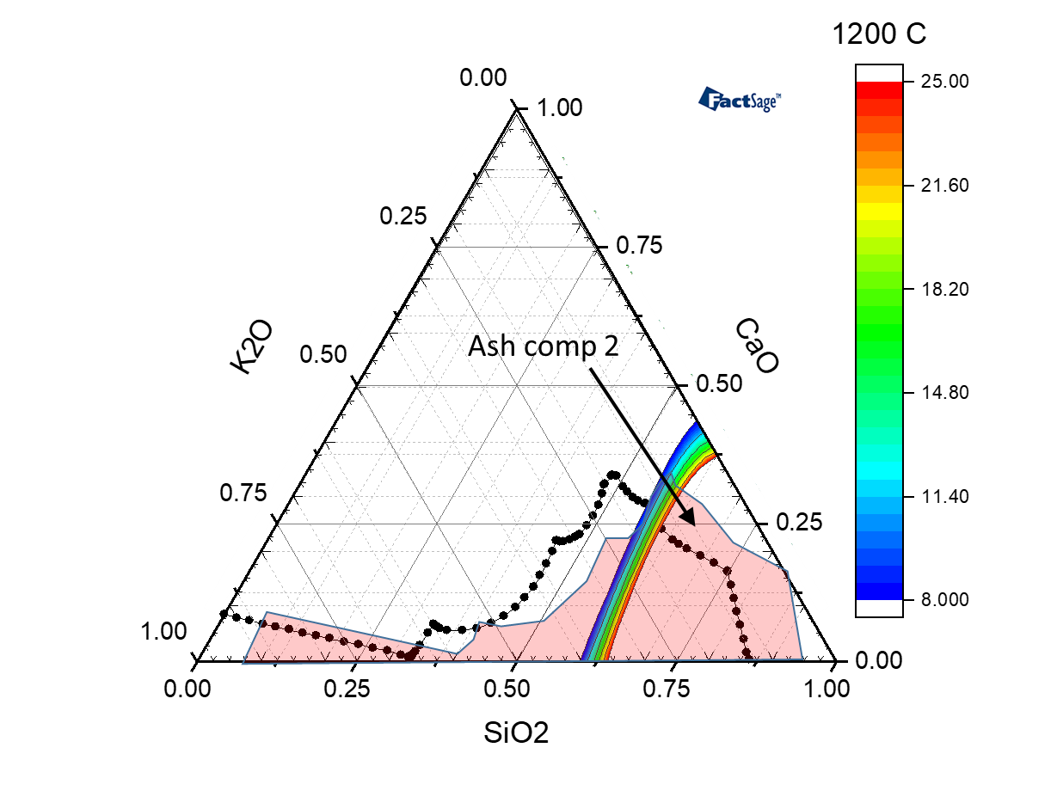 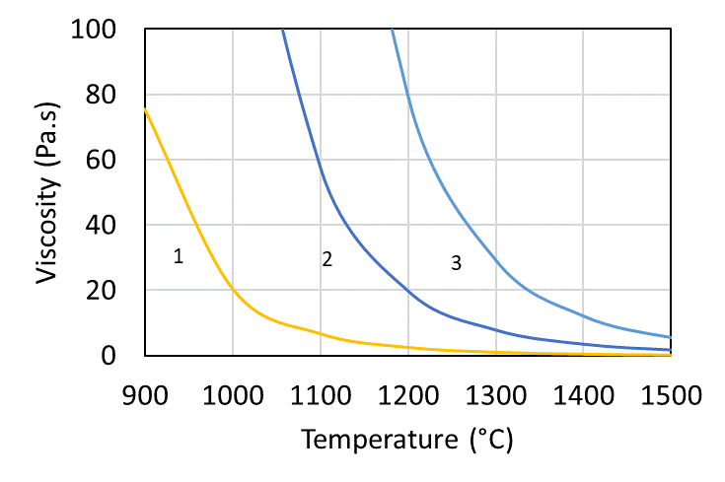

b

a

Figure 1: (a) calculation of viscosity and liquidus boundary at 1200 °C, and (b) change of calculated viscosity of synthetic ash #1, #2 and #3 at 900-1500C.

* + 1. Sintering of synthetic ash

Figure 2(a) shows a synthetic ash pellet collected after premelting treatment. It can be clearly seen that there is no pulverised material left with only bulky melted solid material formed. Figure 2(b) shows SEM images of the same premelted synthetic ash pellet that has a dense and compact structure.

a

b

*Figure 2: (a) Synthetic ash pellet premelted at 900* °C, (b) *SEM image of the premelted ash.*

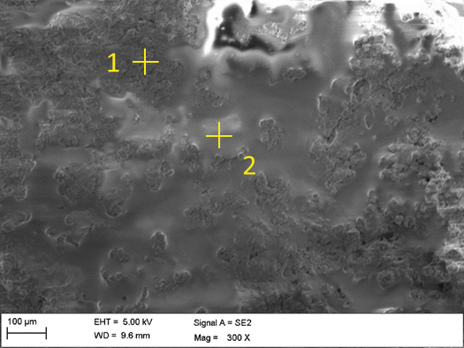 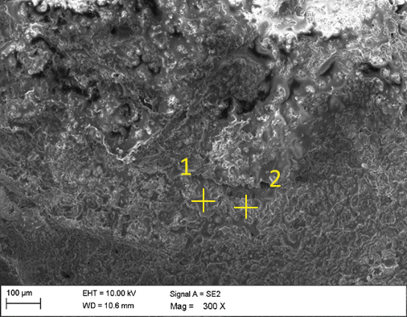 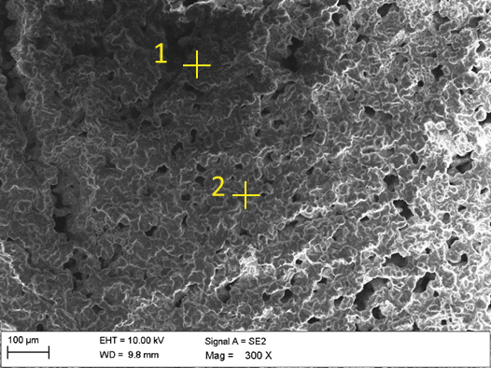

a

c

b

a

*Figure 3: SEM images of premelted synthetic ash (a) #1, (b) #2, and (c) #3.*

Table 2: EDX analysis of premelted synthetic ashes (normalized, mol.%).

|  |  |  |  |  |  |  |  |  |
| --- | --- | --- | --- | --- | --- | --- | --- | --- |
|  |  | SA#1 |  |  | SA#2 | | SA#3 | |
|  |  | 1 |  | 2 | 1 | 2 | 1 | 2 |
| O |  | 54.1 |  | 41.0 | 37.5 | 0.3 | 31.2 | 47.5 |
| Si |  | 25.7 |  | 24.3 | 43.1 | 21.4 | 16.4 | 32.6 |
| K |  | 14.9 |  | 25.4 | 11.4 | 0.7 | 0.5 | 14.2 |
| Ca |  | 5.3 |  | 9.4 | 8.0 | 77.5 | 51.8 | 5.8 |

c

b

a

Figure 4: *SEM images of premelted synthetic ash (a) #1, (b) #2, and (c) #3 after sintered at 1000* °C for 1 hour.

Table 3: EDX analysis of premelted synthetic ashes after sintering at *1000* °C for 1 hour (normalized, mol.%).

|  |  |  |  |  |  |  |  |  |
| --- | --- | --- | --- | --- | --- | --- | --- | --- |
|  |  | SA#1 | | | SA#2 | | SA#3 | |
|  |  | 1 |  | 2 | 1 | 2 | 1 | 2 |
| O |  | 28.9 |  | 21.4 | 61.9 | 59.8 | 61.1 | 45.8 |
| Si |  | 23.7 |  | 27.4 | 21.8 | 18.0 | 23.3 | 20.6 |
| K |  | 32.0 |  | 26.8 | 9.4 | 17.0 | 11.0 | 2.8 |
| Ca |  | 5.4 |  | 24.3 | 5.5 | 1.3 | 4.5 | 30.8 |

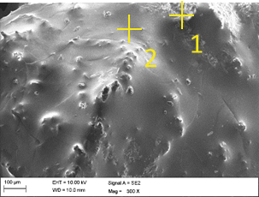 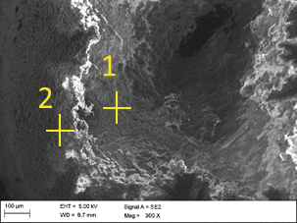

c

b

a

Figure 5: *SEM images of premelted synthetic ash (a) #1, (b) #2, and (c) #3 after sintered at 1000* °C for 1 hour.

Table 4: EDX analysis of premelted synthetic ashes after sintering at *1000* °C for 8 hours (normalized, mol.%).

|  |  |  |  |  |  |  |  |  |
| --- | --- | --- | --- | --- | --- | --- | --- | --- |
|  |  | SA#1 |  |  | SA#2 | | SA#3 | |
|  |  | 1 |  | 2 | 1 | 2 | 1 | 2 |
| O |  | 31.2 |  | 34.1 | 55.9 | 49.5 | 55.6 | 36.7 |
| Si |  | 32.6 |  | 37.2 | 12.8 | 26.8 | 18.5 | 11.2 |
| K |  | 36.1 |  | 21.7 | 3.3 | 0.5 | 15.8 | 11..5 |
| Ca |  | 1.2 |  | 7.0 | 28.0 | 23.0 | 10.1 | 38.6 |

SEM-EDX analysis on premelted synthetic ashes is shown in Figure 3 and Table 2. Two distinctly different morphologies can be observed from the premelted synthetic ash #1 and #3. There is a considerable fraction of the ash #1 that melted completely with a smooth and intact surface (as indicated by spot 2). In contrast, there are small areas with coarse surfaces and grains embedded (as indicated by spot 1 in figure 3). From the melted fraction, a much higher content of potassium was detected with an abundance of Si and Ca, indicating the formation of low-temperature melting potassium-rich silicates.

Figures 4 and 5 show sintering behaviors of premelted synthetic ashes after being heated at 1000 °C for 1 and 8 hours. Synthetic ash #1 shows the highest sintering tendency, which consists primarily of high contents of Si and K. However, as shown in Figure 4(a), there are still fractions of ash with partially melted and sintered structures, with high content of Ca detected. On the contrary, synthetic ash #3 shows poor melting behaviors, and has a coarse surface and is formed with agglomerated particles and grains. The sintering test and SEM analysis agree with viscosity calculation results in that synthetic ash #3 has a low melting tendency at 1000 °C. Upon sintered at 1000 °C for 8 hours, all premelted synthetic ashes had an intense slagging tendency. For synthetic ash #1 and #2, most of their mass is fully fused without any partially melted structure or aggregated grains visible This indicates the extensive melting processes. The disappearance of unfused grains implies an improvement in their viscosity under more intensive heat treatment conditions. The EDX analyses indicate that the sintering behaviors of the studied synthetic ashes are closely related to their chemical composition. The high contents of Si and K were normally identified from the synthetic ash with a high sintering tendency. For the fraction of synthetic ash with mild slagging tendency, high content of Ca was detected with low Si and K contents, indicating the formation of a low viscosity carbonate or calcium-rich silicates that are not likely to form melts and are hence unsuitable for EF gasification.

* 1. Conclusions

In the present study, three synthetic ashes based on the K2O-CaO-SiO2 system with different compositions were studied. The composition of the studied synthetic ashes was proposed by combining FactSage calculation on viscosity, which are close to composition of representative biomass ashes. Sintering tests were further conducted on the synthetic ashes. It was observed that the sintering degree of the synthetic ashes correlates with the initial chemical composition, especially for K and Si. For the synthetic ash after the sintering test, there is a mixture of melts and aggregated grains, and the latter often contains high content of Ca and low Si and K contents. This work enables the selection of biomass feedstocks (including affordable opportunity fuels) with suitable ashes for EF gasification.

Acknowledgments

This work is funded by the Research Council of Norway, through the program for Energy Research (ENERGIX). Projects: FME Bio4Fuels (project number: 257622) and FP FLASH (project number: 280892).

References

Alam, Md Tanvir, Baiqian Dai, Xiaojiang Wu, Andrew Hoadley, and Lian Zhang. 2021. “A Critical Review of Ash Slagging Mechanisms and Viscosity Measurement for Low-Rank Coal and Bio-Slags.” *Frontiers in Energy* 15 (1): 46–67. https://doi.org/10.1007/s11708-020-0807-8.

Bale, C. W., E. Bélisle, P. Chartrand, S. A. Decterov, G. Eriksson, K. Hack, I. -H. Jung, et al. 2009. “FactSage Thermochemical Software and Databases — Recent Developments.” *Calphad*, Tools for Computational Thermodynamics, 33 (2): 295–311. https://doi.org/10.1016/j.calphad.2008.09.009.

Chen, Mao, and Baojun Zhao. 2016. “Viscosity Measurements of the SiO2–K2O–CaO System Relevant to Biomass Slags.” *Fuel* 180 (September): 638–44. https://doi.org/10.1016/j.fuel.2016.04.099.

Defoort, Françoise, Boris Grangier, Thierry Chataing, Serge Ravel, Gilles Ratel, and Sylvie Valin. 2021. “Entrained Flow Gasification of Hardwood Bark: Experimental Characterization of Inorganic Matter versus Equilibrium and Viscosity Predictions.” *Energy & Fuels* 35 (15): 12151–64. https://doi.org/10.1021/acs.energyfuels.1c00993.

Furuvik, Nora C. I. S., Liang Wang, Rajan Jaiswal, Rajan Thapa, Marianne S. Eikeland, and Britt M. E. Moldestad. 2022. “Experimental Study and SEM-EDS Analysis of Agglomerates from Gasification of Biomass in Fluidized Beds.” *Energy* 252 (August): 124034. https://doi.org/10.1016/j.energy.2022.124034.

Ma, Charlie, Rainer Backman, and Marcus Öhman. 2015. “Thermochemical Equilibrium Study of Slag Formation during Pressurized Entrained-Flow Gasification of Woody Biomass.” *Energy & Fuels* 29 (7): 4399–4406. https://doi.org/10.1021/acs.energyfuels.5b00889.

Ma, Charlie, Markus Carlborg, Henry Hedman, Jonas Wennebro, Fredrik Weiland, Henrik Wiinikka, Rainer Backman, and Marcus Öhman. 2016. “Ash Formation in Pilot-Scale Pressurized Entrained-Flow Gasification of Bark and a Bark/Peat Mixture.” *Energy & Fuels* 30 (12): 10543–54. https://doi.org/10.1021/acs.energyfuels.6b02222.

Ma, Charlie, Nils Skoglund, Markus Carlborg, and Markus Broström. 2021. “Structures and Diffusion Motions of K and Ca in Biomass Ash Slags from Molecular Dynamics Simulations.” *Fuel* 302 (October): 121072. https://doi.org/10.1016/j.fuel.2021.121072.

Santoso, Imam, Pekka Taskinen, Ari Jokilaakso, Min-Kyu Paek, and Daniel Lindberg. 2020. “Phase Equilibria and Liquid Phase Behavior of the K2O-CaO-SiO2 System for Entrained Flow Biomass Gasification.” *Fuel* 265 (April): 116894. https://doi.org/10.1016/j.fuel.2019.116894.

Tesfaye, Fiseha, Daniel Lindberg, Mykola Moroz, and Leena Hupa. 2020. “Investigation of the K-Mg-Ca Sulfate System as Part of Monitoring Problematic Phase Formations in Renewable-Energy Power Plants.” *Energies* 13 (20): 5366. https://doi.org/10.3390/en13205366.

Laboratory of Inorganic Chemistry at ÅA University. Åbo Akademi Chemical Fractionation Database; 2012 Available from <https://web.abo.fi/fak/tkf/ook/bransle/>.